Dear future exchange students,
For all students applying for VISA (e.g. Turkey, Taiwan, China…) I need copies of their passports (by email) as soon as possible, by November 1st 2023 at the latest!! I would like to remind you it is strictly required to have a valid passport with the date of expiration at least 6 months after you leave the Czech Republic at the end of your study stay!
Please, complete the online registration, on the link bellow, by November 1st 2023.
After this date your online registration will not be accepted!!!!
https://portal.zcu.cz/portal/studium/uchazec/ects-prijezdy.html?pc_lang=en
Important instructions:
Please FILL IN all mandatory fields marked *.
If you have any problems, please let me know immediately.
1/ first step - ECTS arrival – enter your email address (which you will be using for all the communication with our university) for your verification. Go to the weblink sent to your email afterwards and then you are already on Portal and can fill in the registration

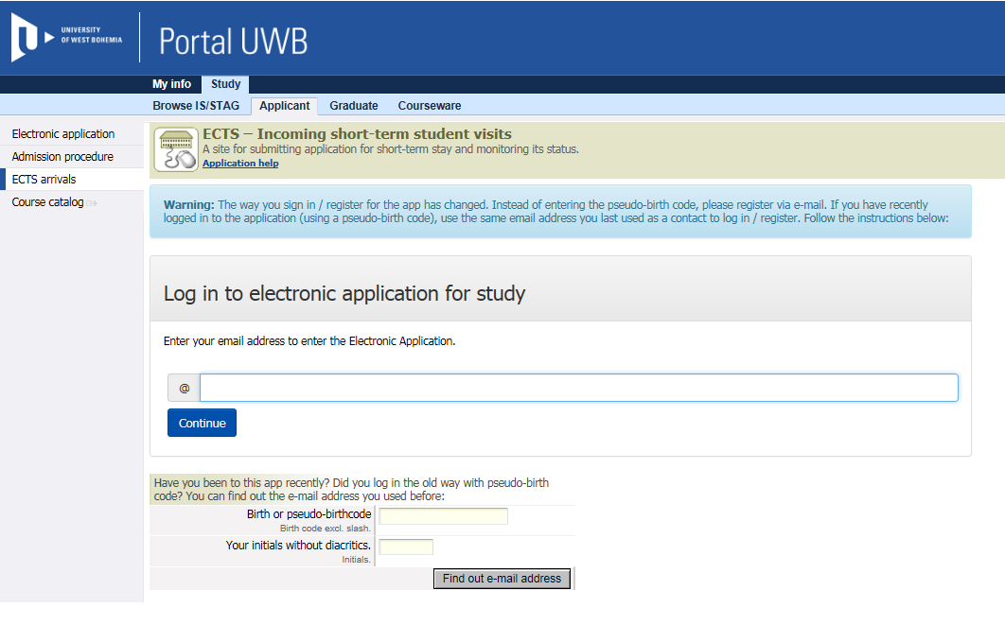

2/ complete the section Personal data and click on „Add Incoming Study Visit“ to activate next menu items:
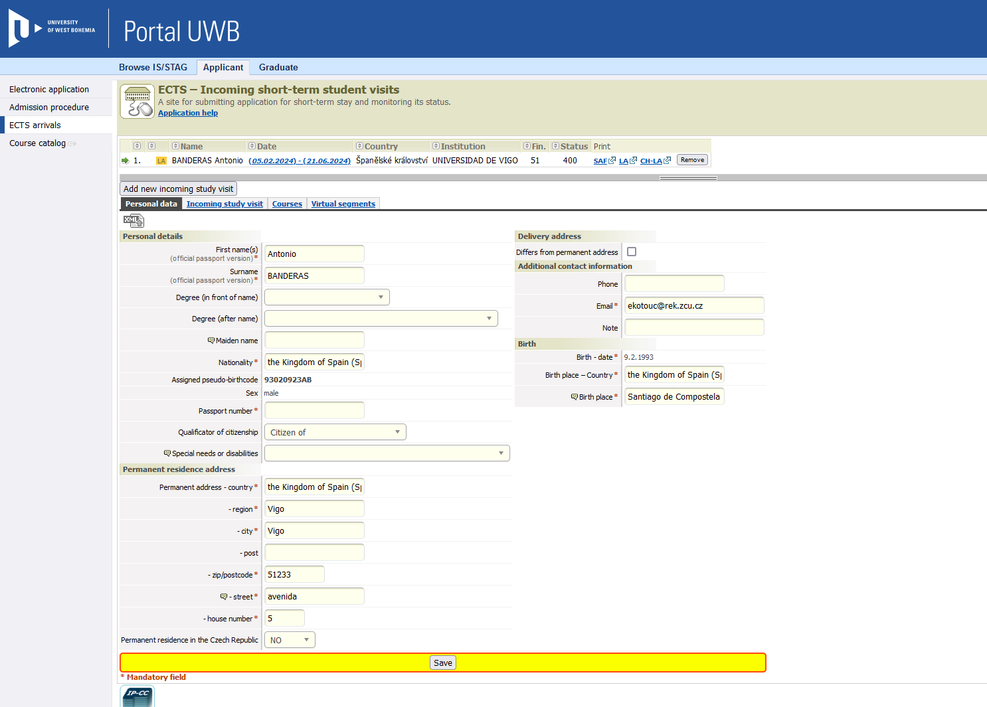
Remember your assigned Birth Code, you will need it several times later and during your stay in Pilsen!!!

3/ click on the section Incoming study visit (top menu) and complete it:
Expected date of arrival/departure (complete expected dates of your stay - IMPORTANT!!), Academic year - 2023/24, Funding – Other form of short term study mobility, Travel type: semester(s) / virtual component (only if applicable), Incoming st. visit type - Short study stay, Accommodation – put „yes“ only if you want a place at the university dormitory. Complete the data about your Home institution.
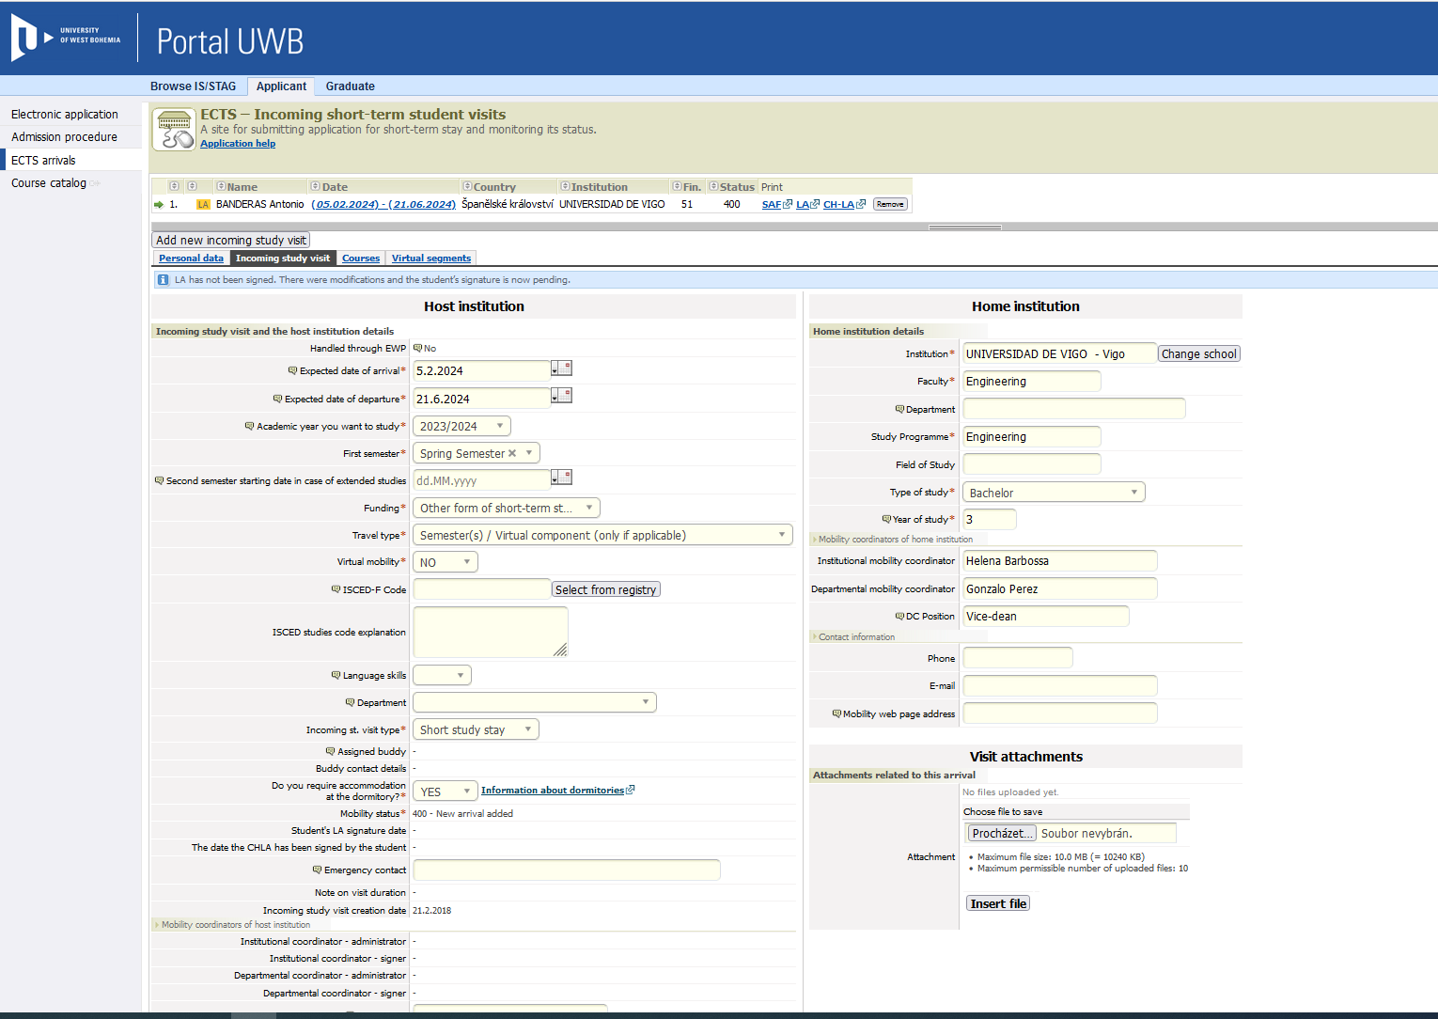

4/ click on the section Courses and complete it:
Click on the faculty you are going to study (choose from the offered list), there you will see all courses, choose one course and click on ADD COURSES, choose another course and click ADD COURSES...... you do not use any „save“ button in this step, it is saved automatically.

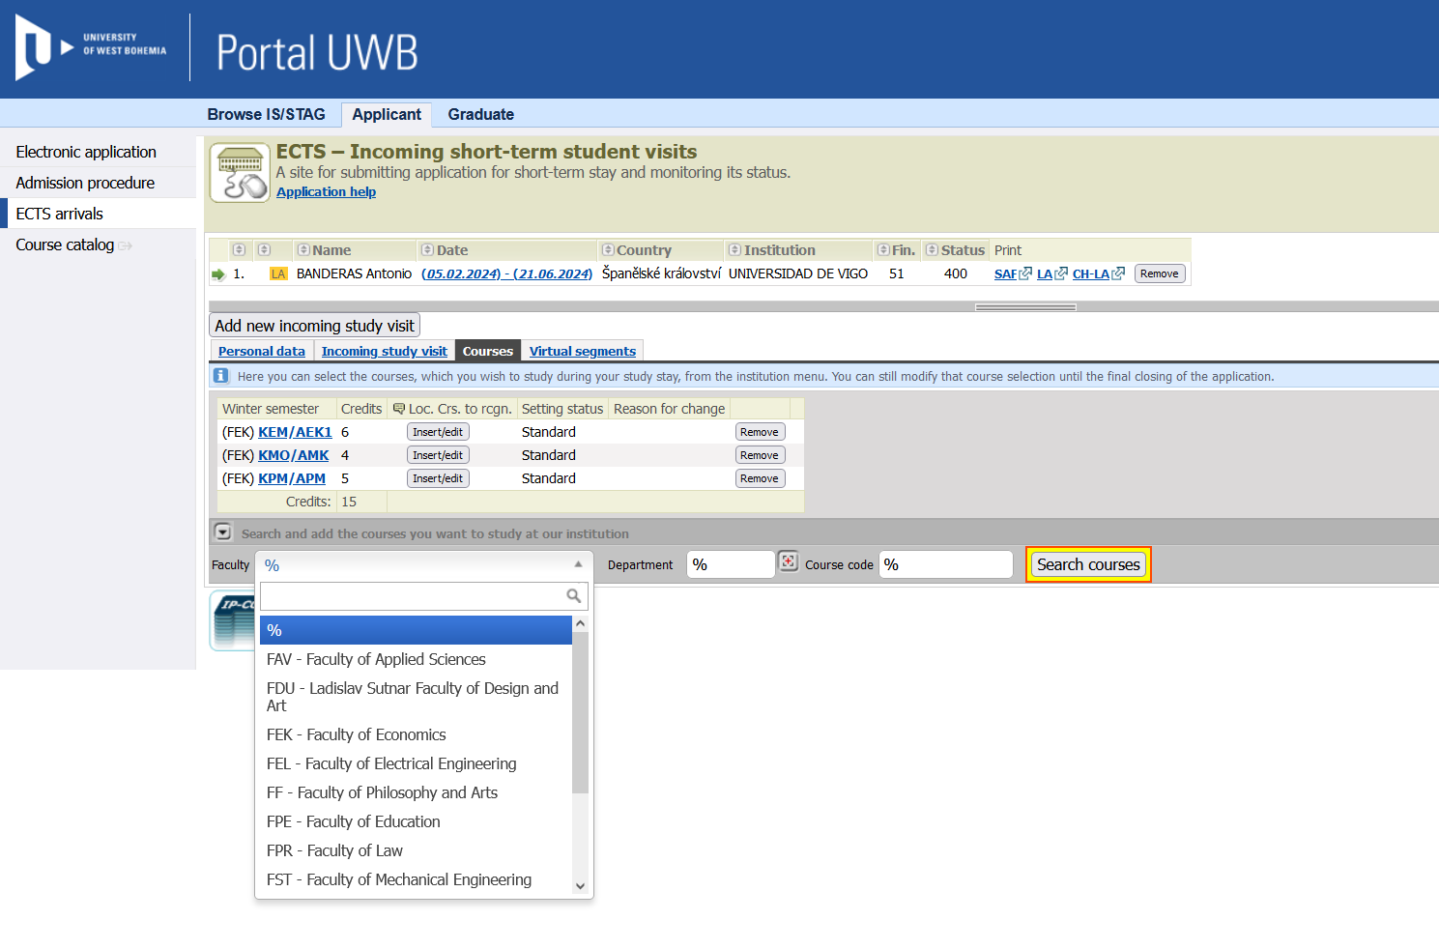
For those of you who are interested in taking Czech language course (equals 5 ECTS credits) follow this link and add the abbreviation of the course to your Learning agreement on portal in section “Courses” as well:
a) Basic Czech 1 (for absolute beginners), code UJP/CZK1
b) Basic Czech 2 (for false beginners), code UJP/CZK2
In case of any doubts with selected courses, please contact the faculty coordinators at UWB (you will find their email adress bellow).
They will confirm if the chosen courses are open.
The faculty coordinators will also check your LA (Learning Agreement) and sign it, send them a scan by email!

Faculty coordinators :

Faculty of Economics (FEK):
Mgr. Ivana KUTÁČOVÁ - ikutacov@fek.zcu.cz
Faculty of Mechanical Engineering (FST):
Martin MELICHAR - mech@fst.zcu.cz …….signs your LA
Nikola SKŘIVANOVÁ – skrivann@fst.zcu.cz …. …. for consultation only
Faculty of Education (FPE):
Tereza HAVRÁNKOVÁ - truzicko@kan.zcu.cz …. for consultation only
Mr.Jan KROTKÝ – conor@kmt.zcu.cz …. signs your LA
Faculty of Electrical Engineering (FEL):
Ing. Jan MICHALÍK, Ph.D. - jmichali@kev.zcu.cz … signs your LA
Ing. Jana ČEČILOVÁ - cecilova@fel.zcu.cz … for consultation only

Faculty of Design and Art (FDU):
Mgr. Markéta KOHOUTKOVÁ - mkohoutk@fdu.zcu.cz

Faculty of Law (FPR):

Ivana JURČOVÁ - jurcova@kup.zcu.cz

Faculty of Philosophy and Arts (FF):

Mrs.Alena TVRDÁ – tvrda@ff.zcu.cz

Faculty of Applied Sciences (FAV):
Ing.Jan POSPÍŠIL, Ph.D. - favint@fav.zcu.cz
Faculty of Health Care Studies (FZS):
Ing. Alena LOCHMANNOVÁ, Ph.D., MBA - lochmann@fzs.zcu.cz

Futher information about the application procedure can be found at:
https://www.international.zcu.cz/en/Exchange_student/application.html

We are looking forward to meeting you!
Eva Kotoučová
ekotouc@rek.zcu.cz (phone: +420 377 635 799, mobile: +420 735 713 961)
Exchange students coordinator
International Office
University of West Bohemia, Plzeň
international.zcu.cz

